OUTSIDE VENDORS .
#1: MANZANILLA KITCHEN #9,10: BOBCAT OF EUREKA
#2,3: TRINITY DIESEL #11: THE RENTAL GUYS
#4,5: FRY BURGER #12: RUTHIE’S ART
#6: LIVING STYLES #14,15: SHED’S UNLIMITED
#7: HIGHER GROUNDS COFFEE #16: CRUNCHY SWEET CREATIONS
#8: ART VENDOR #17,18: RAX ON RAX WINGS

PERFORMERS: SHOSHANA, CALDER JOHNSON, VICTORIA TIMOTEO, ALESSANDRA RUSSO

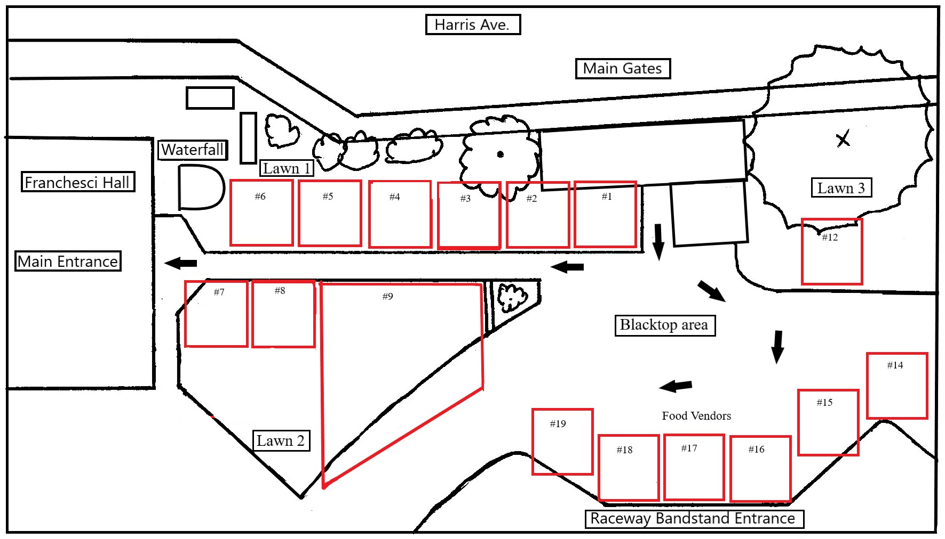

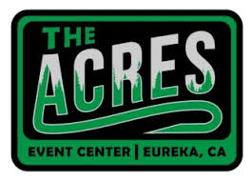

BIG THANKS TO ALL OF OUR SPONSORS: SHAFER’S ACE HARDWARE, SIX RIVERS SOLAR,
THE WATERFALL GUY, THE ACRES EVENT CENTER, MILLER FARMS NURSERY,
POWEL LANDSCAPE MATERIALS, PURE WATER SPAS, COAST CENTRAL CREDIT UNION,
THE MURAL MAN, SUNSONG YOGA & BALANCED SPA

GARDEN CREATORS: MUSIC & TALKS:
GARDEN #1: SINGING TREE NURSERY RON HONIG music (10-12 SAT, 10-12 SUN)
GARDEN #2: J & G LANDSCAPING SOLAR POWER talk (12-1 SAT, 4-5 SUN)
GARDEN #3: LOST FOODS NATIVE NURSERY FLYNN MARTIN duet (1-2/3-4 SAT, 12-1/3-4 SUN)
GARDEN #4: SYNERGY DESIGN LAB H. BOTANICAL GARDEN talk (1-2 SUN)
GARDEN #5: EUREKA FLORIST SCOTT ROBERTSON music (4-6 SAT)
GARDEN #6: SHAFER’S ACE HARDWARE SHOSHANA FAIRY STORY TIME (2-3 SUN)

GUEST JUDGES: MARY GEARHEART (Landscape Designer, BENNY CRAIN (Hum. Botanical Gardens)
BEN FUNKE (Sculptor, Instructor @ Cal Poly & College of the Redwoods, BEN GOULART (Contractor)

INSIDE VENDORS .
SPONSOR BOOTH: SHAFER’S ACE HARDWARE #31: PAINTED FOREST ART
#1,2,3: SHOW SUPPORTER SIX RIVERS SOLAR #32: DISPLAY ART
#4: STATE FARM INSURANCE #33: SEASIDE WEAVERS
#5: TRINITY DIESEL #34: AMBERZ ART
#6: BERKSHIRE HATHAWAY #35: ACCURATE TERMITE
#7, 8: BALANCED SPA #36: BALTIC AMBER
#9,10: LIVING STYLES #37: DISPLAY ART
#11: LOST FOODS NATIVE PLANT NURSERY #38: LELA FACEPAINTER
#12,13: BEER AND WINE #39: ABC ROOFING
#14: BOB’S HEATING #42: BROTHERS GUTTERS
#15: THE WATERFALL GUY #43: MASTER GARDENERS
#16,17: THE MURAL MAN #44: HUMBOLDT BOTANICAL GARDENS
#18: BEN THE GLASS ARTIST #45: PIGEON POINT ARTISANS
#19,20: MILLER FARM SAW SHOP #46: ACCURATE TERMITE
#21: AAA INSURANCE #47: EUREKA FLORIST GARDEN
#22: J & G LANDSCAPING #48: ROOTS & RISE HOLISTIC
#23: THE LAND MAN #49: DISPLAY ART
#24: MARTIN CONSTRUCTION #50: DISPLAY GARDEN
#25,26,27,28: PURE WATER SPAS #51: ART INSTALLATION
#29: ACE HARDWARE #52: ACE HARDWARE
#30: FOREST SERVICES #53: ACE HARDWARE

